**Advance Excel Assignment 3**

*1. How and when to use the AutoSum command in excel?*

Autosum command is used when we need to sum a column or row of numbers.

To use AutoSum in Excel, just follow these 3 easy steps:

1. Select a cell next to the numbers you want to sum:
2. To sum a column, select the cell immediately below the last value in the column.
3. To sum a row, select the cell to the right of the last number in the row.

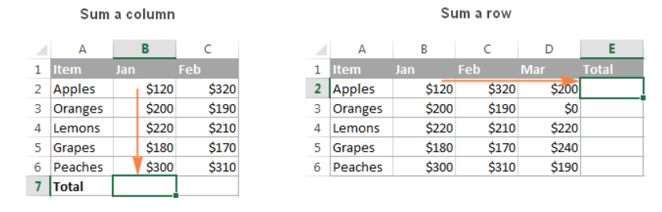

1. Click the AutoSum button on either the Home or Formulas tab.

A Sum formula appears in the selected cell, and a range of cells you're adding gets highlighted (B2:B6 in this example):

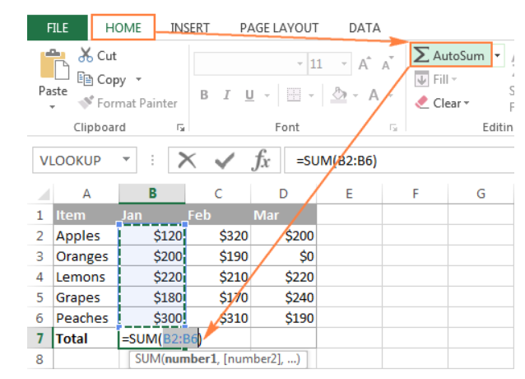

1. Press the Enter key to complete the formula.

Now, you can see the calculated total in the cell, and the SUM formula in the formula bar:

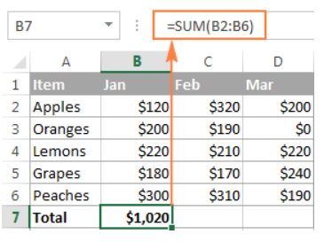

*2. What is the shortcut key to perform AutoSum?*

following is the Excel AutoSum keyboard shortcut to total cells:

=

Alt

Pressing the Equal Sign key while holding the Alt key inserts a Sum formula in a selected cells(s) exactly like pressing the AutoSum button on the ribbon does, and then you hit the Enter key to complete the formula.

*3. How do you get rid of Formula that omits adjacent cells?*

Option #1: Change formulas to include adjacent cells

The first and easiest way to get rid of this error is to adjust your formulas. With this, technically, We have removed the error Excel thought we made.

Option #2: Ignore the Error to remove the green triangle

If your formulas are all set and the error has no relevance to you, you can choose to ignore it. To ignore this error and get rid of the error icons surrounding the relevant cell:

1. Select the cell where the error occurs.The yellow error sign will appear.
2. Click on the drop-down menu icon next to this error sign.
3. Click on Ignore Error from the list and the error icons will go away.

Option#3 : Permanently remove the green triangle for this error.

To permanently remove the green triangle caused by the ‘Formula omits Adjacent cells error’ follow these steps:

1. Go to the File tab > Options.
2. Under the dialog box for Excel Options, go to Formulas from the left pane.
3. Under the section Error checking rules, uncheck the box for Formulas that omit cells in a region.
4. Excel will now no longer pose the Formula omits adjacent cells error.

*4. How do you select non-adjacent cells in Excel 2016?*

There are the two ways to select non-adjacent cells in Excel 2016:-

1. Select Non-Adjacent Cells Using the Mouse

1. Click on the first cell that you want to be selected. This will now become the active cell
2. Hold the Control key on your keyboard
3. Left-click on the mouse and drag to make the selection
4. Leave the mouse click. At this point, you would have a selection. Continue to hold the Control key
5. Place the cursor on the second cell/range that you want to select
6. Left-click on the mouse and drag to make the selection
7. Leave the mouse click. This would select two non-contiguous range of cells.
8. Release the Control key

In case We want to select more than two ranges of non-adjacent cells, keep the control key pressed, and keep making the selections.

2. Select Non-Adjacent Cells Using the Keyboard Only

1. Place the cursor on the first cell that you want to select. This now becomes the active cell
2. Press the F8 key. This will put your system in the ‘Extend Selection’ mode. It also says that in the Status bar.Press F8 for Extended Selection
3. Use the arrow keys to make the selection. Since you’re in the Extend Selection mode, this will keep a selection of all the adjacent cells
4. Hold the Shift key and press the F8 key. This removes the ‘Extend Selection’ mode and changes it to ‘Add or Remove Selection’Add or remove selection
5. Use the arrow keys to place the cursor on the next cell that you want to include in the selection
6. Press the F8 key again.
7. Use the arrow keys to make the selection.
8. Hold the Shift key and press the F8 key. This removes the ‘Extend Selection’ mode.

3. USING NAME BOX

1. To select the cells, first, click on any cell. This marks the cell as the active cell.
2. Now, click on the Name Box in the top-left corner of the spreadsheet.
3. Type the name of the cells separated by a comma in the Name Box. You can enter the name of single cells, or the range of cells separated by a comma.
4. Press Enter. This selects all the non-adjacent cells in the spreadsheet.
5. The non adjacent cells are selected.

*5. What happens if you choose a column, hold down the Alt key and press the letters ocw in quick succession?*

The column width dialogue box opens allowing us to set the exact width of the column.

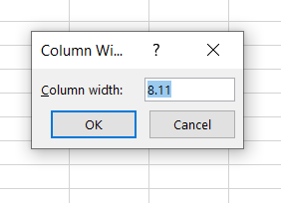

*6. If you right-click on a row reference number and click on Insert, where will the row be added?*

Row will be added above to selected row.